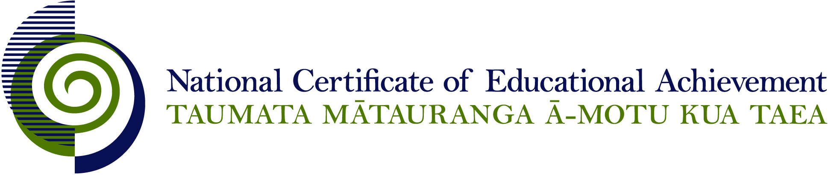

NCEA Level 2 Earth and Space Science

Conditions of Assessment

General Information

Subject Reference | Earth and Space Science
Domain | Science - Core
Level | 2

Conditions of Assessment

These Conditions provide guidelines for assessment against internally assessed Achievement Standards. Guidance is provided on:
- specific requirements for all assessments against this Standard
- appropriate ways of, and conditions for, gathering evidence
- ensuring that evidence is authentic.

Assessors must be familiar with guidance on assessment practice in learning centres, including enforcing timeframes and deadlines. The NZQA website offers resources that would be useful to read in conjunction with these Conditions of Assessment.

The learning centre’s Assessment Policy and Conditions of Assessment must be consistent with NZQA’s Assessment Rules for Schools with Consent to Assess. This link includes guidance for managing internal moderation and the collection of evidence.

Gathering Evidence

Internal assessment provides considerable flexibility in the collection of evidence. Evidence can be collected in different ways to suit a range of teaching and learning styles, and a range of contexts of teaching and learning. Care needs to be taken to allow students opportunities to present their best evidence against the Standard(s) that are free from unnecessary constraints.

It is recommended that the design of assessment reflects and reinforces the ways students have been learning. Collection of evidence for the internally assessed Standards could include, but is not restricted to, an extended task, an investigation, digital evidence (such as recorded interviews, blogs, photographs, or film), or a portfolio of evidence.

Effective assessment should suit the nature of the learning being assessed, provide opportunities to meet the diverse needs of all students, and be valid and fair.

Ensuring Authenticity of Evidence

Authenticity of student evidence needs to be assured regardless of the method of collecting evidence. This must be in line with the learning centre’s policy and NZQA’s Assessment Rules for Schools with Consent to Assess.

Ensure that the student’s evidence is individually identifiable and represents the student’s own work. The evidence must be an accurate reflection of what the student independently knows and can do, according to the Standard being assessed. This includes evidence submitted as part of a group assessment, evidence produced outside of class time or without assessor supervision, and evidence produced with any use of generative artificial intelligence tools (GenAI). GenAI use should be carefully considered in the context of the Standard being assessed and its Conditions of Assessment, discussed with students before the assessment, and its use must be acknowledged. For example, an investigation carried out over several sessions could include:
- teacher guidance on the nature and extent of acceptable GenAI use, if any
- assessor observations and conversations
- meeting with the student at set milestones or checkpoints
- the student’s record of progress, such as photographic entries or any GenAI prompts used.

Specific Information for Individual Internal Achievement Standards

Achievement Standard Number | 91187 Earth and Space Science 2.1
Title | Carry out a practical Earth and Space Science investigation
Number of Credits | 4
Version | 2

The investigation may be carried out in a laboratory or as part of a field trip. Guidelines for the investigation could include the context, and broad conditions such as the availability of equipment or chemicals.

Safety considerations appropriate to the investigation must be provided.

A common context is permissible. Raw data may be collected and processed in small groups but the teacher needs to ensure that there is evidence that each student has met all aspects of the standard.

Discussion with students throughout the investigation in order to clarify ideas and methodology is appropriate.

The teacher can determine the time taken by the assessment as this is dependent on the context being used.

Appropriate technology and software may be used.

Achievement Standard Number | 91188 Earth and Space Science 2.2
Title | Examine an Earth and Space Science issue and the validity of the information communicated to the public
Number of Credits | 4
Version | 2

Assessment against this standard could include, but is not restricted to, a report, poster/infographic or multimedia presentation (for example, PowerPoint, Keynote or any an online presentation tool) presentation.

Evidence can come from, but is not restricted to, any means of communication such as newspapers, websites, television programmes, films, blogs, podcasts and advertisements.

Supporting evidence must be handed in if appropriate to the form of presentation to ensure validity.

The teacher can determine the time taken by the assessment as this is dependent on the form of assessment being used.

Appropriate technology and software may be used.

A common context is permissible.

Achievement Standard Number | 91189 Earth and Space Science 2.3
Title | Investigate geological processes in a New Zealand locality
Number of Credits | 4
Version | 2

Assessment againstthis standard may involve a field trip to collect data and information for this assessment. Data may be collected and processed in small groups but the teacher needs to ensure that there is evidence that each student has met all aspects of the standard.

The teacher can determine the time taken by the assessment as this is dependent on the form of assessment being used.

Appropriate technology and software may be used.

Achievement Standard Number | 91190 Earth and Space Science 2.4
Title | Investigate how organisms survive in an extreme environment
Number of Credits | 4
Version | 2

Assessment against this standard will involve collection of data and information for this assessment. Data may be collected and processed in small groups but the teacher needs to ensure that there is evidence that each student has met all aspects of the standard.

A common context is permissible. Teachers may provide a range of resource material or suggest websites that students select information from. Students may also select their own information.

The teacher can determine the time taken by the assessment as this is dependent on the form of assessment being used.

Appropriate technology and software may be used.

